Java Peresistence with Hibernate

CH1: Introduction
also look on onject databse systems or NoSql systems
see: https://docs.jboss.org/hibernate/orm/5.4/userguide/html_single/Hibernate_User_Guide.html
Persistence in Java
- mapping and stroring object instances in database using sql
- see: SQL and Relational Theory book 2009, Practical Issues in Database Management: A Introduction to Database Systems by Chris Date (Date, 2003) for the theory, cReference for the Thinking Practitioner by Fabian Pascal (Pascal, 2000) and An oncepts, and ideals of (relational) database
SQL
- DDL (Data definition language) for creating, alerting, droping tables and constraints
- DML (Data manipulation language) operations on data, insertionse, update, delete...
- see: join, aggregae, groip, subselects
- see: book on sql SQL Tuning, by Dan Tow (Tow, 2003), Antipatterns: Avoiding the Pitfalls of Database Programming (Karwin, 2010)
SQL in Java
-JDBC API
- in DB you have Item and Bid tables, so in Java you have Item and Bid classes, so the app loads and stores instaces of this classes in db. So business logic is in java app, not in db we can use object-oriented concepts -> relation modelind and object modeling paradigms (object/relational paradigm)
Object/relational paradigm mismatch
- add one object in java class, but in db save in same table
- inhertiance
- problem of the object identity. DB equals by primary key. In Java in same time more objects that represnt same row of the database. Primary key needs to be update in the foreing key valuee (use surrogate keys)
Associations
- in Java use object refernces in DB foreing key represents an associations
- references are pointers, from one instance to the other so if assocation between instances shpud be navigable in both directions you must define association ntwice, once in each of the classes
- navigation has no meaning for the DB, beacuse it's done by join and projections
- also problem is many to many in DB you must have new table where in java you do not need new object.
class User {
Set Adress Adresses;
}
class Adress {
Set User users;
}
Data navigation problem
- must minimize the number of requests to the DB, but also if you retrive too much data, you're wasting memory in the app. Use lazy loading (retrive data on demand)
ORM AND JPA
JPA specification that defines
- how persistent classes and their properties relate do the DB schema
- apis for crud operaions
- apis for queirs
- how persistence engine interacts with transactional instances
ORM
- transforms data from one representation to another
Hibernate is ORM framework that implements JPA specification
CH2 Starting a project
Hibernate
- ORM service, with collection of data management tools
have:
1. Hibernate ORM (core)
2. Hibernate EntityManager (impl. of the JPA-a)
3. Hibernate Validator (declarative validation for domain model)
4. Hibernate Envers (logging, keeping multiple versions of data in SQL database)
5. Hibernate Search (api for query)
6. Hibernate OGM (support for NoSQL solutions)
Starting point in JPA is persistence unit (paring domain model class with DB connection and other configuration settings). Persistence unit (DB) app can have more then one
All SQL statements executed by Hibernate can be logged
Second step is to write and mapp persistent classes
- every persisten entity class must have at least @Entity annotation and identifier attribute annotated with @Id
- @GeneatedValuse annotation enables automatic generation of IDs
IF two instance of class have the same id value, they represent the same row in the database
Next step is storing and loading data from DB. You must create EntityManagerFactory to talk DB (represents presistence unit)
Every interaction with db shold occur within explict transaction bounddaries.
Hibernate automatically detect modification and do update not save.
The native equivalent of the JPA EntityManagerFactory is the org.hibernate.SessionFactory (usually one per application)

CH3 Domain models and metadata
JPA doesn’t require that persistent classes implement java.io.Serializable. But when instances are stored in an HttpSession or passed by value using RMI, serialization is necessary.
Persistence class can't have final methods, and can not be nested class. Can be abstract, can extend non-persistent class or implement an interface. Must have a constructor with no arguments.
Hibernate (and JPA) require a constructor with no arguments for every persistent class.
We prefer to prefix Hibernate annotations with the full org.hibernate.annotations package name. Consider this good practice, because you can easily see what metadata for this class is from the JPA specification and which is vendor-specific.
For a property mapped as a persistent collection, you should return exactly the same collection instance from the getter method that Hibernate passed to the setter method. If you don’t, Hibernate will update the database, even if no update is necessary, every time the state held in memory is synchronized with the database.
If Hibernate uses accessor methods when loading and storing instances and a RuntimeException (unchecked) is thrown, the current transaction is rolled back, and the exception is yours to handle in the code that called the Java Persistence (or Hibernate native) API. If you throw a checked application exception, Hibernate wraps the exception into a RuntimeException.
POJO associations
- if have bidirectilanal associations use scaffolgin code. Also remove set methods for the lists
// scaffolding code START
b.setItem(i);
i.getBids().add(b);
// scaffolding code END
Bean Validation rules
- idea propert can't be null, number has to be in the given range and so on
- use annotaions @NotNull, @Size, @Future (time must be in future)
- can create your own annotations, can be applied to class or filed level
Sometimes—for example, when you want to write some custom validation or generic UI code—you’d like to get programmatic access to the persistent attributes of an entity you can use (Metamodel mm = entityManagerFactory.getMetamodel();)
Hibernate JPA2 Metamodel Generator to generate metada class of entity class. Used in sql as replacement for strings. Generate class is abstract name is enttiy_ Example:
@javax.persistence.metamodel.StaticMetamodel(Item.class).
public abstract class Item_ {
<enter/>
public static volatile SingularAttribute<Item, Long> id,
public static volatile SingularAttribute<Item, String> name;
public static volatile SingularAttribute<Item, Date> auctionEnd;
<enter/>
}
Old way:
from.get.("name")
New way:
from.get(Item_.name);
It can be integrated in IDE, pr use maven build.

CH4 Mapping persistend classes
Entity - entities in the real world
value types - other types in domain model Adress, String, Integer
Ex: Db user have stret, city, zipcode, but in java app (domain model) you have User that have Adress object, also same with email
Some instances of object may not have their own identitiy and life cycle but depend on others ( value types)
Ex: User is entity class, have adress propery (Address class). You have two user instances, do they use same reference fo Adress, (problem) or does each User instance have a reference to its own Address.
Rule: If Adress is supposed to suport shared reference, it's a entity type (have its own life, you can not delete it when one instace of User dies, because other need to used it).
If Adress can be deleted when User dies, other instance of User have own Adress object then it's value type.
Entity have its persistend identifier (id), but value type has no persistend identifier, it belongs to an entity instance (In java like String, Integer).
First step when mapping decide is it entitiy or value type.
The Item and User classes are obvious entities. They each have their own identity, their instances have references from many other instances (shared references), and they have independent lifespans.
Marking the Address as a value type is also easy: a single User instance references a particular Address instance. You know this because the association has been created as a composition, where the User instance has been made fully responsible for the life cycle of the referenced Address instance. Therefore, Address instances can’t be referenced by anyone else and don’t need their own identity.
It can happend one class can be value for other, but entity for some else class. So then must ne entity. You’ll often find this kind of mixed behavior; but your first reaction should be to make everything a value typed class and promote it to an entity only when absolutely necessary
In the code:
- avoid shared reference to value type instances. Make sure only one user can reference Address. Makr Adresss immutable, with no public setUser()
- if a usre is deleted adress must be delete as well (cascading rules)
- entity class need an id, value classes don't need it
Mapping identity on entities
== -> objects are same it they occupy the same memory location
equals -> object are same it they have sam values
database identity -> objects are same it they have the same primary key value
primary key: neve null, unique, immutable (neve changes).
Hibernate do not allow update on primary key
@Id annptation is required to mark the identifier propery of an entity class. Without the @GeneratedValue, JPA assumes that you'll take care of creating and assigning an id before save.
Also if @Id is on a field, the JPA provider will access fields of the class directly and consider all fields part of the persistent state by default.
@GeneratedValue(strategy = ...):
- AUTO, Hibernate ask sql dialect for appropriate strategy
- SEQUNECE, Hibenrate generate sequence brere insert in db (hib_sequences tabel)
- IDENTITY, db is generateing pk intable (must be seted in db, on every insert)
- TABLE, Hibernate will use an extra table in you db shema (hibernate_sequences for maintaing the sequences), very slow
Most applications work with database sequences, but you may want to customize the name and other settings of the database sequence. Therefore, instead of picking one of the JPA strategies, we recommend a mapping of the identifier with @GeneratedValue(generator = "ID_GENERATOR"). JPA has two built-in annotations you can use to configure named generators: @javax.persistence.SequenceGenerator and @javax.persistence.TableGenerator.
Also you can use hiberante native @org.hibernate.annotations.GenericGenerator annotation. Here is the recommended configuration:
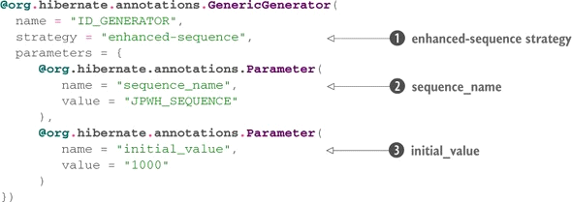
strategy:
- native: same sa AUTO
- sequence: natie db sequence, caleed before each INSERT
- sequnece-identity: generate key by calling a db sequence on insertion, key is retried after insert
- enhanced-sequences: db sequence, calls the db before insert
- seqhilo: db sequence, optipimiing calls before insert
- hilo: use an extra table hibernate_uniqe_key same as seqhilo algorithm
- enhanvced-table
- identiy
-increment
- select
- uuid2
- guid
Prefer pre-insert generation strategies that procude id values before insert, use enhanced-sequence.
For Id use synthetic identifiers, also called surrogate keys. Surrogate keys have no business meaning—they have unique values generated by the database or application. Do not use natural key (defined by bussines)
You can override the table name with the JPA @Table annotation
@Entity
@Table(name= "xyz") ...
hibernate.auto_quote _keyword=true to automatically put quotes around keywords string when generating sql
Hibernate provides a feature that allows you to enforce naming standards automatically. Suppose that all table names in CaveatEmptor should follow the pattern CE_<table name>
see: org.hibernate.boot.model.naming.PhysicalNamingStrategy interface - be carefoul when write sql
Dynamic sql genratio of crud sql on app start or when neede, use when need if you have much rows in db
@org.hibernate.annotations.DynamicInsert
@org.hibernate.annotations.DynamicUpdate
mark class @org.hibernate.annotations.Immutable if update is never gona happedn, it is imutable.
Using Hibernate annotation you can create an app-level view, a read-only entity class mapped to an SQL select
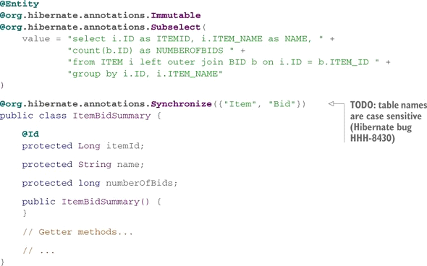
When istance of ItemBidSummary is loaded, Hibernate executes you custom sql selecet as subselect:
ItemBidSummary itemBidSummary = em.find(ItemBidSummary.class, ITEM_ID);
best practice use sequence (hibernaten optimization) idententy or
CH5 Mapping value types
By default all persistent property are nullable and optional
If the property is a primitve or a wraper ist's automuatically persistent
@Embeddable (class, or on filed level) maps the property as an emnedded component of the owing class
If the type is Serializable, its value is stored in its serialized form
Overriding basic propery defaults
To exclude a propery from being persistend mark it with @Transient annotation
@NotNull or @Column(nullable = false) to make property not null
You can override the mapping or the propery name to the db column
@Column(name = "xyz")
The persistence engine accesses the properties of a class throught fileds or getter methods. It depeneds where you put @Id annotation
@Acess(AcessType.PROPERTY/FILED) - to set access strategy
PROPEDTY -> getter or setter
FILED -> filed
The value of a derived property is calculated at runtime by evaluating an SQL ecpression declated with @Formula (only in select, not update and insert)
@org.hibernate.annotations.Formula("substr(DESC, 1, 12) || '...'")
private String shortDesc;
@ColumnTransformer annotation for convert/transorm value of the db column when reading and writing a row
@Column(name="xyz")
@org.hibernate.annotations.ColumnTransformer(
read = "xyz / 12"
write = "? * 2.045"
)
private double weight;
this is added aslo in select
The database sometimes generates a property value, usually when you insert a row for the first time. Marking properties as generated, however, lets the application delegate refresing entity to Hibernate. GenerationTime can be ALWAYS or INSERT
Also The JPA specification requires that you annotate temporal properties with @Temporal to declare the accuracy of the SQL data type of the mapped column. The Java temporal types are java.util.Date, java.util.Calendar, java.sql.Date, java.sql.Time, and java.sql.Timestamp.
Example:
@Temporal(TemporalType.TIMESTAMP)
@Column(insertable = false, updatable = false)
@org.hibernate.annotations.Generated(
GenerationTime.ALWAYS
)
private Date lastModified;
Explanation:
- @Temporal = temporal property must set type
- @Column(insertable = false, updatable = false), never appera in the insert or update
-@Generated, can be ALWASY (after every insert or update) or INSERT (only after insert)

@CreationTimestamp
- generate propery automatically, before insert
@UpdateTimestamp
- generate update automatically
see: org.hibernate.annotations.GeneratorType and ValueGenerationType
Enums
@NotNull
@Enumerated(EnumType.STRING)
private AccType type = AccType.XYZ;
- without @Enumerated hibernate would store java ordinal value (index of filed in enum class, (1, 2 3, ..))
Mapping Embeddable componenets
db -> user ID, USERNAME, FIRSTNAME, LASTNAME, STREET, ZIPCODE, CITY
java class User { Strring userName... Adress adress } class Adress { String street... }
make class with @Embeddable
- no id propery
- inherit access strategy from their owning entity
- override equals and hashCode
Note hibernate stores null so if you store User with an "empthy" Adress it will return null. Probably shoud't have nullable columns (all must have values).
The @AttributeOverrides selectively overrides property mappings of the embedded class; in this example, you override all three properties and provide different column names. This means the @Column annotations on the Address class are ignored
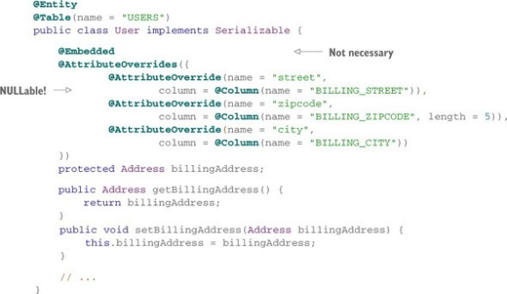

Mapping Java and Sql types : Build in types
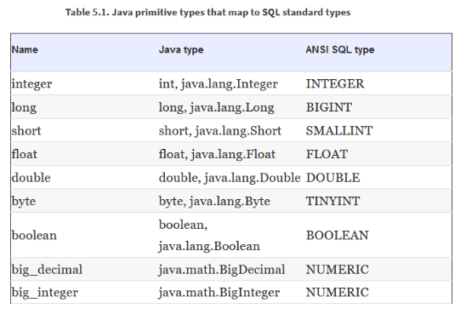
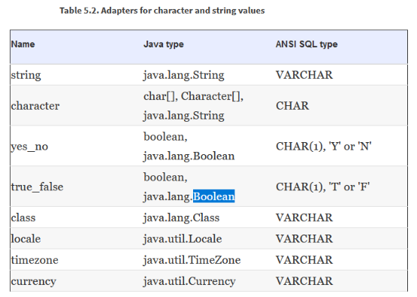
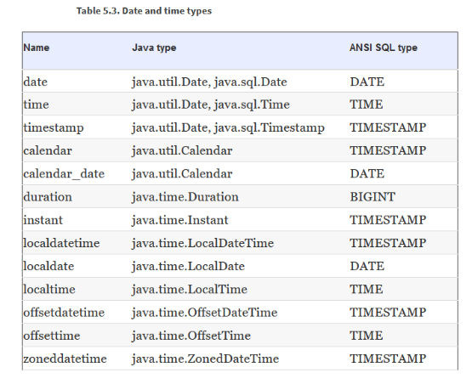
Do not bind th domain model to types from the JDBC packagre.
(Hibernate has to use the JDBC subclass when loading data from the database because the database types have higher accuracy than java.util.Date. A java.util.Date has millisecond accuracy, but a java.sql.Timestamp includes nanosecond information that may be present in the database. Hibernate won’t cut off this information to fit the value into java.util.Date. This Hibernate behavior may lead to problems if you try to compare java.util.Date values with the equals() method)
Always compare date and time by comparing time in miliseconds (a.getTime() > b.getTime())
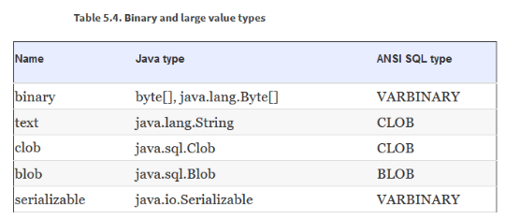
byte[] -> maps it or VARBINARY
Hibernate initializes the property when the entitiy instance is loaded, This is inconvenient when you have to deal with large values, you shoud override mapping with @Lob
Ex:
@Lob
private byte[] image;
@Lob
private String description;
it will map byte to blobl and String to clob. It does not do lazy loading, yous mappes data.
If your Java property is java.sql.Clob or java..sql.Blob you will hava lazy loading automatically.
Lobs (Blob, Clob) they are locator objects, placeholders that helps us access the real thing.
Hibernate you can directly into db load ans save
Blob b = session.getLobHelper().createBlob(inpustStresam, bytheLength);
@org.hibernate.annotations.Type(type = "yes_no") override default tyoe selection.
It will now create char with values Y or N
Custom JPA data type conventer
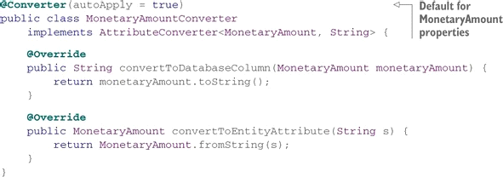
conventer has to implements the AttributeConventer interface
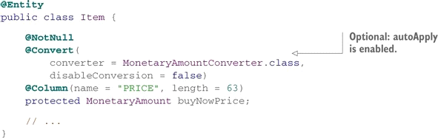
also be carfeul how MonetaryAmountConverte.class shoud look like
see: native Hibernate UserType API

CH6 Mapping inheritance
Strategies:
- one table per concrete class and default runtime polymorphic behavior
- one table per concreta class, discard polymorphisam and inheritance relatioship from sql schema, use union queries for runtime polymorphic behavior
- one table per class hiearchy, enable polymorphims by denormalizing sql schema and relying on roe-based discrimintaion to determint super/subtypes
- use one table per subclass. is a repationshi is represnet as has so use join sql operations
Table per concrete class with implicit polymorphism
One table for each concrete class.
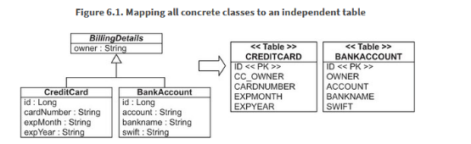
Map concrete classes with @En tity. By default properties ot the superclass are ignored and not persistent. Annotate superclass with @MappedSuperclass.
In concretre class use @AttributeOverride
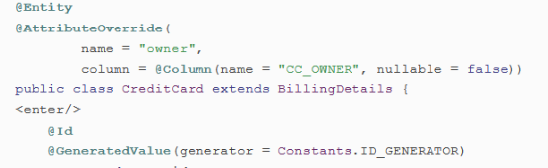
Hibernate uses a separate SQL query for each concrete subclass. On the other hand, queries against the concrete classes are trivial and perform well—Hibernate uses only one of the statements.
We recommend this approach (only) for the top level of your class hierarchy, where polymorphism isn’t usually required, and when modification of the superclass in the future is unlikely.
Table per concrete class with unions
identifire and its mapping in abstrac claass (superclass) are perssisent and sharedit to all subclasses
@Entity and @Inheritence(strategy= InheritanceType.TABLE_PER_CLASS) is required on superclass
@Entitiy annotation on each sublacc is al that is required.
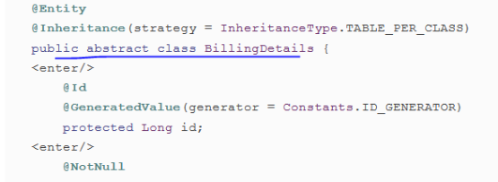
DB is not aware of the inheritacen, the table look same as in image 6.1.
In background tables are combined with a UNION operator
Table per class hierarchy.
Map an entire class hierarchy to a single table.
Best performance and most simple. Columns for properties declared by subclasses must be nullable, aslo problem is normalization.
In abstract class use: @Entity, @inheritance(strategy single_table), @DiscriminatorValue(name = 'xzy')
DiscriminatorColumn .used by hibernate to distingusih what each row represents
In concrete class marke as @Entity, @DiscriminatorValue(name = 'xzy') and set NotNull
Also see @org.hibernate.annotations.DiscriminatorFormula()
Table per subclass with joins
Inheritance relationship as SQL foreign key associations. Every class that have persistent (abstract included) has its own table
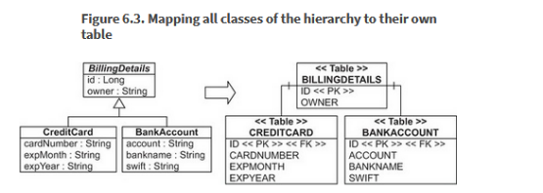
On CreditCard save hibernate inserts two rows. The values in BillingDetails table, and The values of CredCard table. PK is shared by the two rows links them together. Normalize the sql schema
in abstrac class put @Entity, @Inheritance(strategy JOINED), discriminator value is not required.
In sublcasses you don't need to specify id column ( if you wish the same name for PK)
you mak as @Entity (@PrimaryKeyJoinColumn(name = "CREDITCARD_ID") if you wish specifiy the pk)
Hibernate does sql outer join. Performace can be problem becaues of join's, ans compilicatred sql queries also can be
You can not chanege inheritance strategy once you mapped it. You can use some tricks see @SecondaryTable annoataions
Inheritance of embeddable class
Use the @MappedSuperclass annotation on the superclass of the embeddable class you’re mapping just like you would for an entity. Subclasses will inherit the properties of this class as persistent properties
TODO read more
Choosing a strategy
- depends on usage of the superclass, consider how frequentily you query for instancef of superclasses, alao does subtypes have many addistional attributes or only different behavior
if you don't require polymorphic associations or queries (lean toward table per concrete class) An explicit UNION-based mapping with InheritanceType.TABLE_PER_CLASS should be preferred, because (optimized) polymorphic queries and associations will then be possible later.
If you require polymorphic assocations use InheritanceType.SINGLE_TABLE.
If you do require polymorphic associations or queries, and subclasses declare many (non-optional) properties (subclasses differ mainly by the data they hold), lean toward InheritanceType.JOINED. Alternatively, depending on the width and depth of your inheritance hierarchy and the possible cost of joins versus unions, use InheritanceType.TABLE_PER_CLASS. This decision might require evaluation of SQL execution plans with real data
choose InheritanceType.SINGLE_TABLE only for simple problems.
for complex cases, or when a data modeler insisting on the importance of NOT NULL constraints and normalization overrules you, you should consider the InheritanceType.JOINED strateg
you can’t put inheritance annotations on interfaces; this isn’t standardized in JPA
Polymorphic many to one associations to a class that have many subclasses
@ManyToOne(fetch = FetchType.LAZY)
protected BillingDetails defaultBilling;
Hibernate automaticy handle this.
Be careful if you have FetchType.LAZY, hiobernate will return prosy obj not some of the impl of BillingDetails classes, so instance of is not working and you will aslo get class cast exception, so To perform a proxy-safe typecast, use em.getReference()
Polymorphic one to many associations to a class that have many subclasses
@OneToMany(mappedBy = "user")
protected Set<BillingDetails> billingDetails = new HashSet<>();
Abstaact class can not be mapped @MappedSuperclass it must be mapped as @Entity and @Inheritance must be set
Summary
Table per concrete class with implicit polymorphism is the simplest strategy to map inheritance hierarchies of entities, but it doesn’t support polymorphic associations very well. In addition, different columns from different tables share exactly the same semantics, making schema evolution more complex. We recommend this approach for the top level of your class hierarchy only, where polymorphism isn’t usually required and when modification of the superclass in the future is unlikely.
The table-per-concrete-class-with-unions strategy is optional, and JPA implementations may not support it, but it does handles polymorphic associations.
The table-per-class-hierarchy strategy is a winner in terms of both performance and simplicity; ad hoc reporting is possible without complex joins or unions, and schema evolution is straightforward. The one major problem is data integrity, because you must declare some columns as nullable. Another issue is normalization: this strategy creates functional dependencies between non-key columns, violating the third normal form.
The table-per-subclass-with-joins strategy’s primary advantage is that it normalizes the SQL schema, making schema evolution and integrity constraint definition straightforward. The disadvantages are that it’s more difficult to implement by hand, and performance can be unacceptable for complex class hierarchies.

CH7 Mapping collections and entity associations
DB on delete cascade option - when app delete row in the table delete also delete rows referencing this row on other tables
Java - use an interface to declate the type of the property, initialite with implementation in the same line. Do not do it in collections.
Set<String> images = new HashSet<String>();
Combinations
- Set, new HashSet -> no order, no duplicates
- SortedSet, TreeSet -> yes order, no duplicates
- List, ArrayList -> perserves postions, add index colum in the db
- Collection, ArrayList -> duplicates ok, no order
- Map, HashMap -> key and valuse save in db
Create custom persistent collections extend PersistentCollection interface
If you don't specify the type with generics you need to set @ElementCollection or @MapKeyClass
File and Files aren' transactionsl -> transacion can finish but file is not saved

Mapping a set
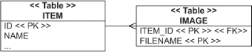
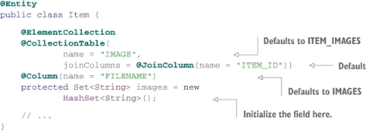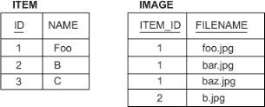
@ElementCollection - for a collection of value-typed elements, (embeded, image has no life cycle on his own, one direciton repations, you can not from image go to item).
Also posible is this - surogate PK (item_id)
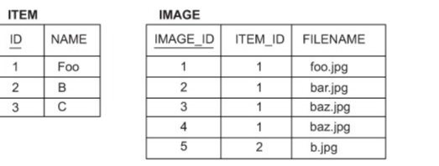

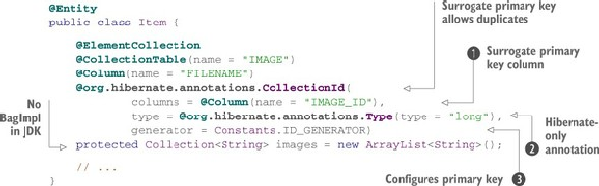

Mapping a list
@OrderColumn. This column stores an index in the persistent list, starting at zero (do not confuse with sorting - this is not sorting, (soring do on select))
Indroduce new colum in the db that holds order info.
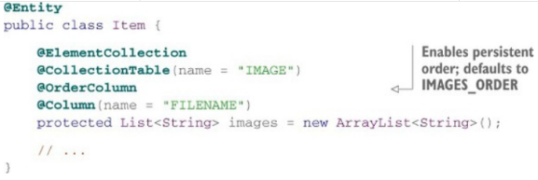
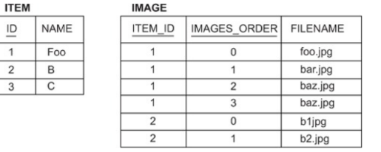
Mapping a map
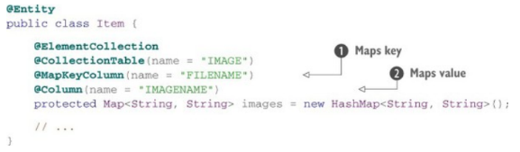
Map doesn't allow dupicate keys.
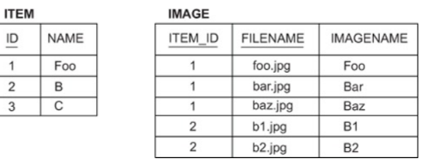Ž
If the key is a Java enum, you must use @MapKeyEnumerated. With any temporal types such as java.util.Date, use @MapKeyTemporal.
You sort a collection in memory using a Java comparator. You order a collection when it’s loaded from the database, using an SQL query with an ORDER BY clause.
@org.hibernate.annotations.SortComparator(ReverseStringComparator.class)
protected SortedMap<String, String> images = new TreeMap<String, String>();
one more example:
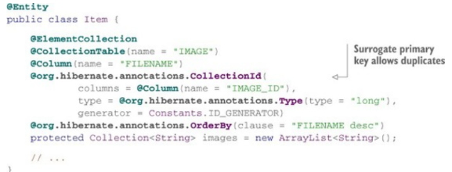
Mapping entity associations
unidirectional many-to-one association
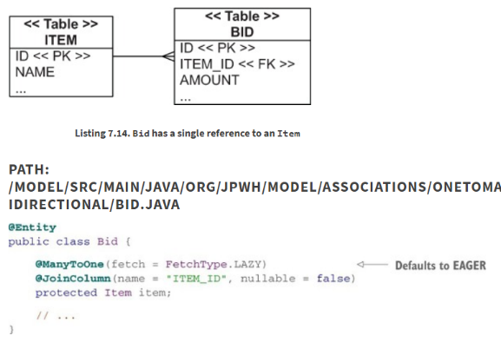
A many-to-one entity association maps naturally to a foreign key column: ITEM_ID in the BID table
Note: Ask yourself if any table in the schema will have a BID_ID foreign key column. If not, map the Bid class as @Embeddable, not @Entity, using the same tables as before but with a different mapping with fixed rules for transitive state changes.
bidirectional many-to-one association
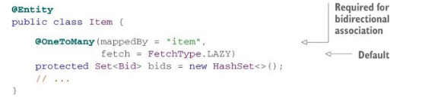
have to set the mappedBy parameter. The argument is the name of the property on the “other side.”
The mappedBy parameter is always required when the one-to-many is bidirectional, when you already mapped the foreign key column.
Cascading state
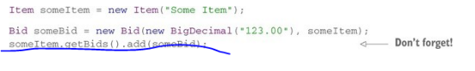to save all bids when the item is saved, map the collection
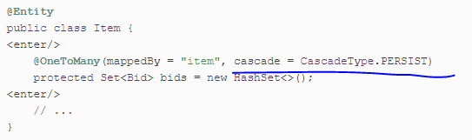
At commit time, Hibernate examines the managed/persistent Item instance and looks into the bids collection. It then calls persist() internally on each of the referenced Bid instances, saving them as well.
also on delete:
@OneToMany(mappedBy = "item",
cascade = {CascadeType.PERSIST, CascadeType.REMOVE})
protected Set<Bid> bids = new HashSet<>();
TODO SEE: diff betwen orphanRemoval (ONLY @OneToMany)= true and CascadeType.Persist
and
@org.hibernate.annotatons.OnDelete....

CH8 Advanced entity association mappings
One to one associations
Sharing a primary key strategy.
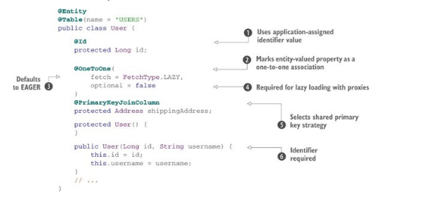
@PrimaryKeyJoinColumn - shared primaty key strategy
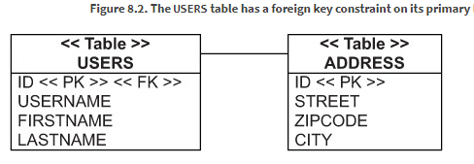
this is undirectional shared PK
After persisting the Address, you take its generated identifier value and set it on the User before saving it, too.
bidirectional mapping always requires a mappedBy side
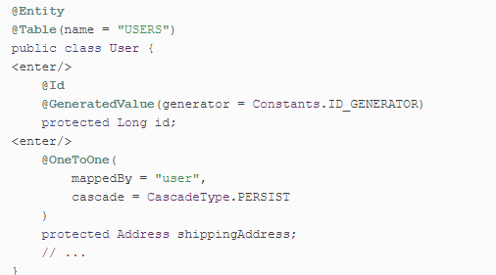
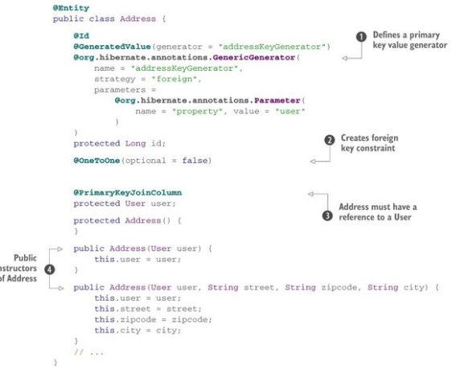
Instead of sharing a primary key, two rows can have a relationship based on a simple additional foreign key column.
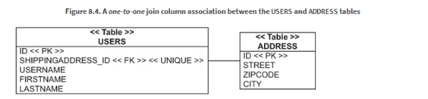
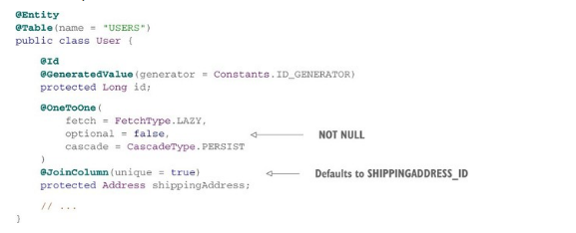
instead of @PrimaryKeyJoinColumn, you apply the regular @JoinColumn.
If you’re more familiar with SQL than JPA, it helps to think “foreign key column” every time you see @JoinColumn in a mapping.
using join table
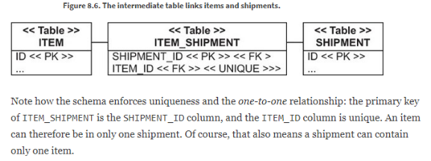
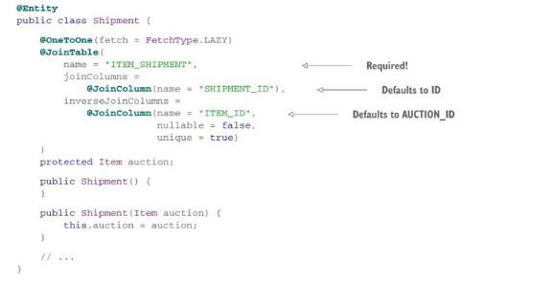
To summarize, use a shared primary key association if one of the two entities is always stored before the other and can act as the primary key source. Use a foreign key association in all other cases, and a hidden intermediate join table when your one-to-one association is optional
One to many associations
Can be done with onw to many bags - best performance fo bidirectional one to many entitiy associations.
To map a bidirectional one-to-many association as a bag, you have to replace the type of the bids collection in the Item entity with a Collection and an ArrayList implementation
Optional one to many with join table
An optional entity association, be it one-to-one or one-to-many, is best represented in an SQL database with a join table.
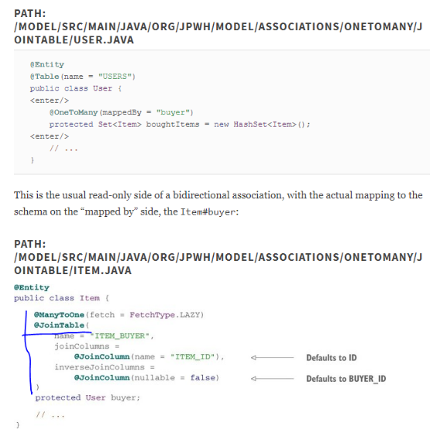
Many to many associations.
A join table in the database represents a regular many-to-many association, which some developers also call the link table, or association table.
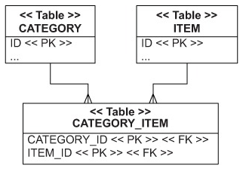
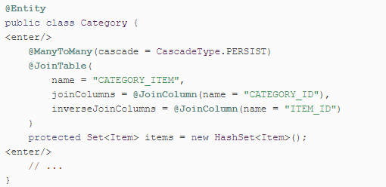
for bidirectional add this in Item:
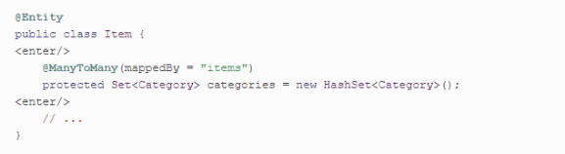
Cascading options: ALL, REMOVE, orphan deletion aren't meangful for many to many associations.
TODO many to many with intermediate entity
TODO Ternary associations
TODO Entity associations with maps
CH9 Complex and legacy schemas
Hibernate bundles the class org.hibernate.tool.hbm2ddl.SchemaExport with a main() method you can run from the command line. This utility can either talk to your DBMS directly and create the schema or write a text file with the DDL script for further customization by your DBA.
You can hook the following types of custom sql scripts into Hibernate's schema generation process:
- create script
- drop script
- load script (before your application or unit test runs)
define indexes
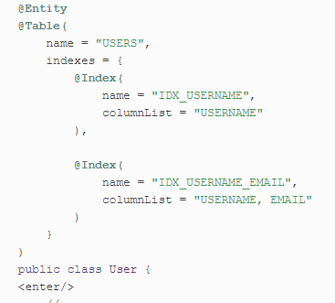
see: SQL Tuning by Dan Tow for DB optimization

CH10 Managing data
Write app logic that's unaware whather the data operates on persistent state or taty exits only in memory. The app shouldn't need to care that an instance is pesistent when invoking its methods. You have to call the Java Persistance instacne only to store and load data to propagate state held in memory to db or vice versa.
Applicaton must concern itself with:
life cycle of entity (persisience life cycle)
unit of work (state-changign atomic opertion, managed scope)
persisence contex from persistence service (remebers all the modifications adn state changes in unit of work)
Entity instance states
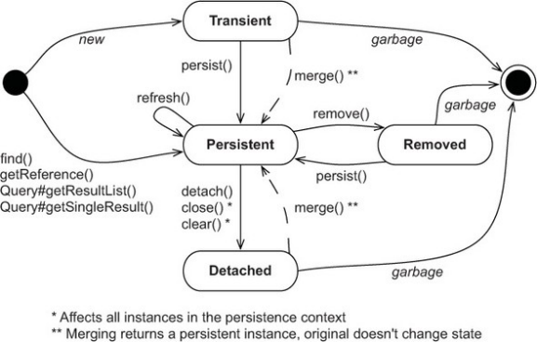
transient
- creatend with new operator, state is lost and garbage-collected as soon as they're no longer referenced or out the scope.
persistent
- from transient to persistens state you need to call EntityManager->persisit, or enable cascading of state from already persistent object or with fetch
- have repersation in db or will be stored when unit of work completes (have db identity)
- can be retrived throught query, lookup, or navigation the object graph
- delete from db using call EntityManager->remove or remove reference form mapped collection if have orphan remove enabled. Programer is responsible for discarding any reference that app may hold -> it goes to detached state after end of unit of work is deleted
Persistence contex
- created on EntityManagerFactory->createEntityManager(), closed on EntityManager->close()
- monitors and manages all entites in pesistend state (in much cases one per application)
- persistence engine can perform automactic dirty checking (detect modifications)
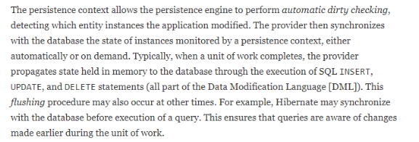
The persistence context acts as a first-level cache; it remembers all entity instances you’ve handled in a particular unit of work.
Consider the comparison of references entityA == entityB. This is true only if both are references to the same Java instance on the heap. Now, consider the comparison entityA.getId().equals(entityB.getId()). This is true if both have the same database identifier value. Within one persistence context, Hibernate guarantees that both comparisons will yield the same result.
EntityManager interface
- provieds service for basic CRUD operations, use EntityManager, to create units of work
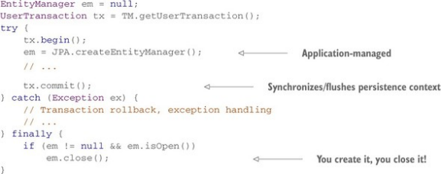
Everything between tx.begin() and tx.commit() occurs in one transaction, completely either succeed or fail.
You can also force dirty checking synchronization manually by calling EntityManager#flush() at any time during a transaction. ( it will do only on commit)
Making data persistent
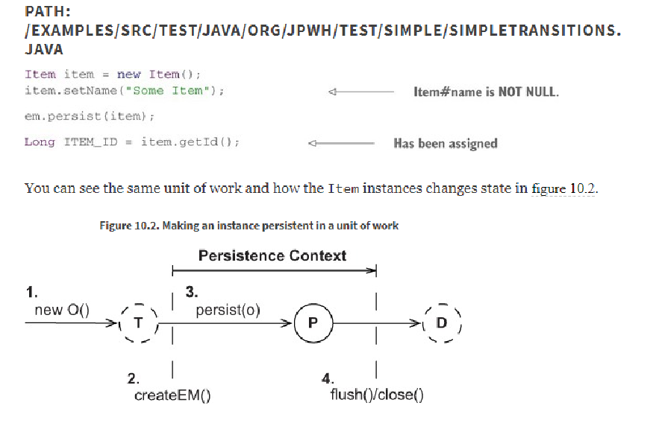
A call to persist() makes the transient instance of Item persistent.
To store the Item instance in the database, Hibernate has to execute an SQL INSERT statement.
When the transaction of this unit of work commits, Hibernate flushes the persistence context, and the INSERT occurs at that time.
When you call -persist(), only the identifier value of the Item is assigned (if your identifier generator isn’t pre-insert, the INSERT statement will be executed immediately when persist() is called)
persistent -> EntityManager#contains(e) if return true
transient -> PersistenceUnitUtil#getIdentifier(e)returns null (PersistenceUnitUtil from EntityManagerFactory)
detached -> not persisten and PersistenceUnitUtil#getIdentifier(e)returns the value.
Note:
There are two issues to look out for. First, be aware that the identifier value may not be assigned and available until the persistence context is flushed. Second, Hibernate (unlike some other JPA providers) never returns null from Persistence-UnitUtil#getIdentifier() if your identifier property is a primitive (a long and not a Long).
Retriving and modifying persistent data
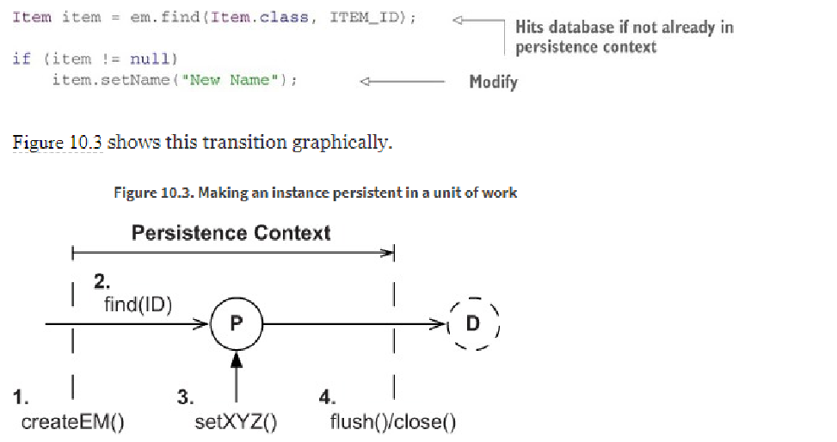
You can modify the Item instance, and the persistence context will detect these changes and record them in the database automatically. When Hibernate flushes the persistence context during commit, it executes the necessary SQL DML statements to synchronize the changes with the database
You may want to customize how Hibernate detects dirty state
em.getReference()
if persistance context already have obj, db is not accesed. Then use PersistenceUnitUtil#isLoaded() to chek is initialized
Hibernate.initialize, to initialize data
Load the data before you close the persistence context.
em.find() -> allways hits the DB
Making data transient
- to remove the state of an entity instance from the db you must to make it transient. Call te
remove()
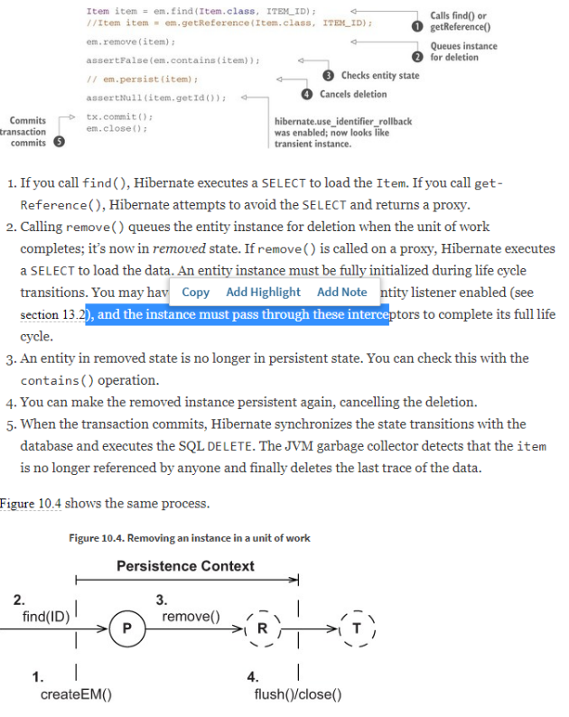
Hibernate won’t alter the identifier value of a removed entity instance.
if you set the property hibernate.use_ identifier_ rollback to true in persistence.xml, Hibernate will reset the identifier value after removal of an entity instance.
Refresh data held in memory
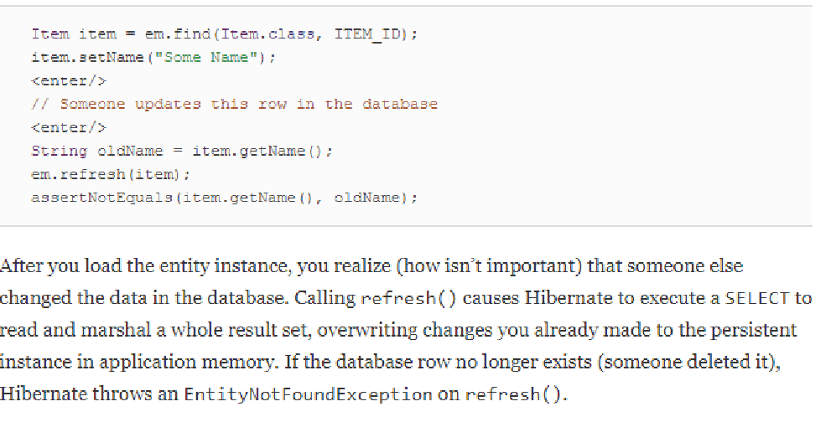
Replication is useful, for example, when you need to retrieve data from one database and store it in another. Replication takes detached instances loaded in one persistence context and makes them persistent in another persistence context.
The replicate() operation is only available on the Hibernate Session API
Caching in the persistence context
The persistence context is a cache of persistent instances. Every entity instance in persistent state is associated with the persistence context.
Many Hibernate users who ignore this simple fact run into an OutOfMemory-Exception. This is typically the case when you load thousands of entity instances in a unit of work but never intend to modify them. Hibernate still has to create a snapshot of each instance in the persistence context cache, which can lead to memory exhaustion.
You can call EntityManager#detach(i) to evict a persistent instance manually from the persistence context. You can call EntityManager#clear() to detach all persistent entity instances, leaving you with an empty persistence context.
The native Session API has some extra operations you might find useful.
Flushing the persistence context
by default hibernate flushes the persistence contex of an EntityManager and synchronize changes when: transaction is commited, when a query is executed, app calls flush() explicity
You can control this behavior with FlushModeType setting of an EntityManager.
You can at any time, while a transaction is in progress, force dirty checking and synchronization with the database by calling EntityManager#flush()
Working with detached state
Whenever you work with instances in detached state and you test them for equality (usually in hash-based collections), you need to supply your own implementation of the equals() and hashCode() methods for your mapped entity class.
A seemingly clever approach is to implement equals() to compare just the database identifier property this is not good, becaues id is assgine on persist, os object that are not perssit will not be equlas.
Solution: We argue that essentially every entity class should have a business key (natural key), even if it includes all properties of the class. The business key is what the user thinks of as uniquely identifying a particular record, whereas the surrogate key is what the application and database systems rely on
equals() method code always accesses the properties of the “other” reference via getter methods. This is extremely important, because the reference passed as other may be a Hibernate proxy, not the actual instance that holds the persistent state.
Deteaching entity instances
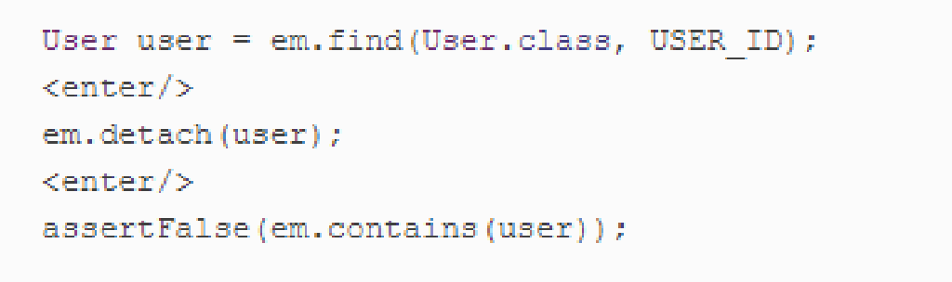
You can now work with the user reference in detached state. Many applications only read and render the data after the persistence context is closed. Modifying the loaded user after the persistence context is closed has no effect on its persistent representation in the database. JPA allows you to merge any changes back into the database in a new persistence context, though
Merging entity instances
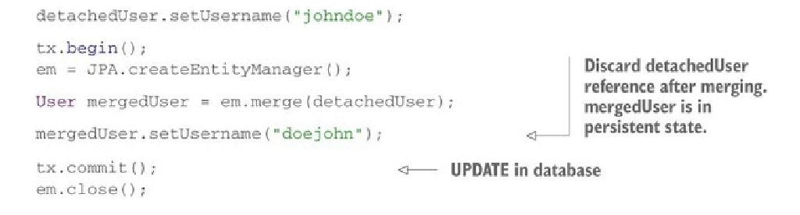
An application architecture based on detachment and merging may not call the persist() operation. You can merge new and detached entity instances to store data. The important difference is the returned current state and how you handle this switch of references in your application code. You have to discard the detachedUser and from now on reference the current mergedUser. Every other component in your application still holding on to detachedUser has to switch to mergedUser
The Hibernate Session API has a method for reattachment called saveOrUpdate(). It accepts either a transient or a detached instance and doesn’t return anything
If you want to delete a detached instance, you have to merge it first. Then call remove() on the persistent instance returned by merge()

CH11 Transactions and concurrency
Unit of woek is an atomic group of operaions. Transactions allow you to set unit of work boundaries and help you isolate one unit of work from another. In a multiuser application, you may also be processing these units of work concurrently.
ACID
atomicity, consistency, isolation, durability
We have system and database transactions.
A single database transaction usually involves only a single batch of database operations. To execute all of your database operations inside a system transaction, you have to set the boundaries of that unit of work. → transaction demarcation
Transaction boundaries that begin and end a transaction can be set either programmatically in application code or declaratively
Programmatic transactions with JTA
JDBC API
→ setAutoCommit(false)
→ end transaction by calling commit()
→ can at any time force rollback()
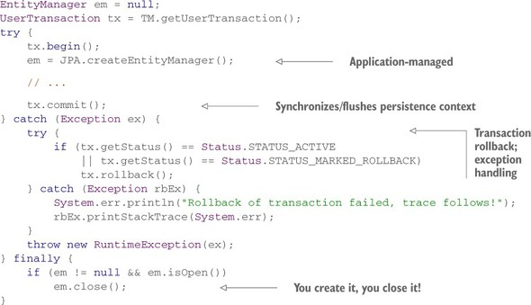
If unit of work access more the one transactional resource, JDBC can not do it alone so use JTA → UserTransaction interface (begin(), commit()) Some of the JTA providers: Bitronix, Atomikos. Use JTA do not use hibernate Transaction of EntityTransaction
Note: EntityManager and JTA (UserTRansaction) is lazy
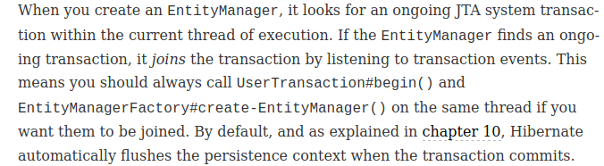
Always commit your transaction and roll back if the commit fails. The exception for rollback requires special treatment: you want to catch this exception and log it; otherwise, the original exception that led to the rollback is lost.
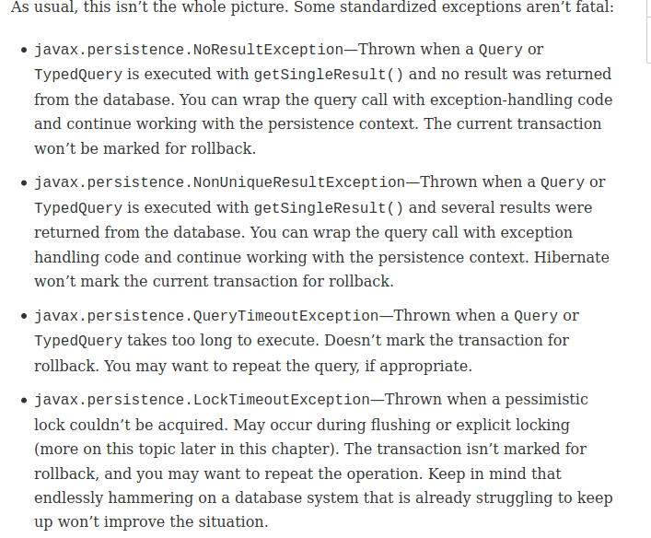

Declarative transaction handling
You can apply @javax.transaction.Transactional
stao 11.2

